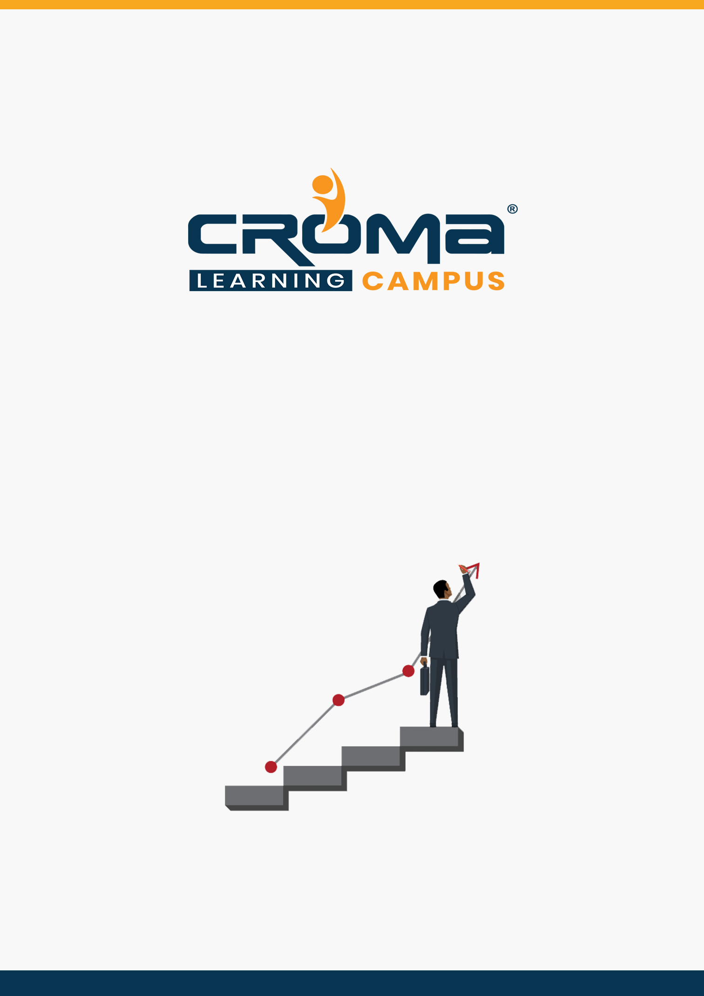

**AZ-104 Microsoft Azure Administrator Training Curriculum**

**STRUCTURE**

**www.cromacampus.com | helpdesk@cromacampus.com | +91-120-4155255**

**AZ-104 Microsoft Azure Administrator Training Curriculum**

*“Become a Microsoft Certified Azure Administrator by joining our comprehensive AZ-104 Microsoft Azure Administrator Training Program”*

**Course Objectives:**

* Prepare yourself for the certification exam and clear your certification exam in the first attempt
* Add an attractive credential in your resume that is really appreciated by Companies.
* Improve your overall cloud management skills and explore more job prospects with better salary packages.
* Boost your social media profiles especially LinkedIn by adding this certification and become one of the top persons to be chosen by industries.

**AZ 104 Certification Training Description:**

The Azure Administrator implements, manages, and monitors identity, governance, storage, compute, and virtual networks in a cloud environment. The Azure Administrator will provision, size, monitor, and adjust resources as appropriate. Candidates should have a minimum of six months of hands-on experience administering Azure.

Candidates should have a strong understanding of core Azure services, Azure workloads, security, and governance. Candidates for this exam should have experience in using PowerShell, the Command Line Interface, Azure Portal, and ARM templates.

**Necessary Details about Certification You must Know**

* Certification Name – AZ-104: Microsoft Azure Administrator
* Exam Duration: 180 minutes
* Number of Questions: 40-60
* Passing score: 700 (Out of 1000)
* Exam Cost: USD 165.00
* Validity: 2 years

**Certification Exam Structure:**

* Manage Azure identities and governance (15-20%)
* Implement and Manage Storage (10-15%)
* Deploy and Manage Azure Compute Resources (25-30%)
* Configure and Manage Virtual Networking (30-35%)
* Monitor and Backup Azure Resources (10-15%)

**Course Content:**

**Module 1: Manage Azure identities and governance (15-20%)**

* Manage Azure AD objects
  + create users and groups
  + manage user and group properties
  + manage device settings
  + perform bulk user updates
  + manage guest accounts
  + configure Azure AD Join
  + configure self-service password reset
  + NOTE: Azure AD Connect; PIM
* Manage role-based access control (RBAC)
  + create a custom role
  + provide access to Azure resources by assigning roles
  + subscriptions
  + resource groups
  + resources (VM, disk, etc.)
  + interpret access assignments
  + manage multiple directories
* Manage subscriptions and governance
  + configure Azure policies
  + configure resource locks
  + apply tags
  + create and manage resource groups
  + move resources
  + remove RGs
  + manage subscriptions
  + configure Cost Management
  + configure management groups

**Module 2: Implement and Manage Storage (10-15%)**

* Manage storage accounts
  + configure network access to storage accounts
  + create and configure storage accounts
  + generate shared access signature
  + manage access keys
  + implement Azure storage replication
  + configure Azure AD Authentication for a storage account
* Manage data in Azure Storage
  + export from Azure job
  + import into Azure job
  + install and use Azure Storage Explorer
  + copy data by using AZ Copy
* Configure Azure files and Azure blob storage
  + create an Azure file share
  + create and configure Azure File Sync service
  + configure Azure blob storage
  + configure storage tiers for Azure blobs

**Module 3: Deploy and Manage Azure Compute Resources (25-30%)**

* Configure VMs for high availability and scalability
  + configure high availability
  + deploy and configure scale sets
* Automate deployment and configuration of VMs
  + modify Azure Resource Manager (ARM) template
  + configure VHD template
  + deploy from template
  + save a deployment as an ARM template
  + automate configuration management by using custom script extensions
* Create and configure VMs
  + configure Azure Disk Encryption
  + move VMs from one resource group to another
  + manage VM sizes
  + add data discs
  + configure networking
  + redeploy VMs
* Create and configure containers
  + create and configure Azure Kubernetes Service (AKS)
  + create and configure Azure Container Instances (ACI)
  + NOT: selecting a container solution architecture or product; container registry settings
* Create and configure Web Apps
  + create and configure App Service
  + create and configure App Service Plans
  + NOT: Azure Functions; Logic Apps; Event Grid

**Module 4: Configure and Manage Virtual Networking (30-35%)**

* Implement and manage virtual networking
  + create and configure VNET peering
  + configure private and public IP addresses, network routes, network interface, subnets, and virtual network
* Configure name resolution
  + configure Azure DNS
  + configure custom DNS settings
  + configure a private or public DNS zone
* Secure access to virtual networks
* create security rules
* associate an NSG to a subnet or network interface
* evaluate effective security rules
* deploy and configure Azure Firewall
* deploy and configure Azure Bastion Service
* NOT: Implement Application Security Groups; DDoS
* Configure load balancing
  + configure Application Gateway
  + configure an internal load balancer
  + configure load balancing rules
  + configure a public load balancer
  + troubleshoot load balancing
  + NOT: Traffic Manager and Front Door and Private Link
* Monitor and troubleshoot virtual networking
  + monitor on-premises connectivity
  + use Network Performance Monitor
  + use Network Watcher
  + troubleshoot external networking
  + troubleshoot virtual network connectivity
* Integrate an on-premises network with an Azure virtual network
  + create and configure Azure VPN Gateway
  + create and configure VPNs
  + configure ExpressRoute
  + configure Azure Virtual WAN

**Module 5: Monitor and Back up Azure Resources (10-15%)**

* Monitor resources by using Azure Monitor
  + configure and interpret metrics
  + analyze metrics across subscriptions
  + configure Log Analytics
  + implement a Log Analytics workspace
  + configure diagnostic settings
  + query and analyze logs
  + create a query
  + save a query to the dashboard
  + interpret graphs
  + set up alerts and actions
  + create and test alerts
  + create action groups
  + view alerts in Azure Monitor
  + analyze alerts across subscriptions
  + configure Application Insights
  + NOT: Network monitoring
* Implement backup and recovery
  + configure and review backup reports
  + perform backup and restore operations by using Azure Backup Service
  + create a Recovery Services Vault
  + use soft deletes to recover Azure VMs
  + create and configure backup policy
  + perform site-to-site recovery by using Azure Site Recovery
  + NOT: SQL or HANA

**Module 6: Placement Guide**

* Tips to clear an Interview
* Common Interview questions and answers
* AZ 104 Interview Questions and Answers
* Resume Building Guide
* Attempt for AZ 104 Global Certification Exam
* Earn Credentials and Start applying for Jobs